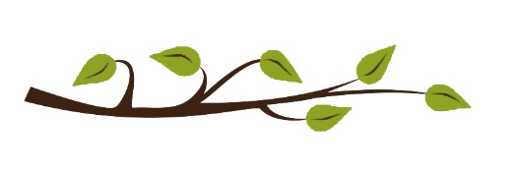

2026 CLINTONVILLE AREA COMMISSION ELECTION

If the idea of advocating on behalf of your community and working with the City of Columbus sounds like something you’d like to do, then run for a Clintonville Area Commission seat in the upcoming 2026 Election!
Districts on the ballot this year are numbers 1, 2, and 9. Boundaries for these districts are:

District 1: Bounded on the south by the Glen Echo Ravine, on the east by the railroad tracks just east of Indianola, on the north by the center line of Weber Road, and on the west by the center line of High Street.

District 2: Bounded on the south by the Glen Echo Ravine, on the east by the center line of High Street, on the north by the center line of Orchard Lane, and on the west by the Olentangy River.

District 9: Bounded on the south by the Columbus City limits and the eastward projection of the Columbus city limits (west of High Street) and by the center line of Georgetown Drive and its westward projection and the south line of the State Schools for the Blind and Deaf (east of High Street), on the east by the railroad tracks just east of Indianola, on the north by the city limits of Worthington, and on the west by the Olentangy River and the Columbus city limits.

If you are interested in running for a seat, please pick up a printed Candidate Petition Packet at the front desk of Whetstone Library beginning June 12th.

Candidates will have until July 13th to collect the required number of signatures and submit a complete Candidate Petition Packet. Election Day is Saturday, August 22.

