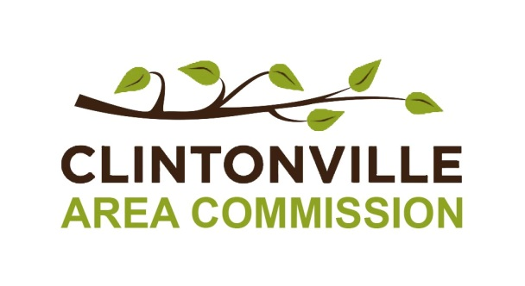
Resolution 2015-__
Resolution 2016-__

Recommending the Establishment of an Architectural Review Area for the
High Street and Indianola Avenue Commercial Corridors of Clintonville

Recitals

- Whereas a central charge of the Clintonville Area Commission is to bring community concerns or problems to the attention of the City of Columbus and to suggest possible solutions.

- Whereas Clintonville is facing increasing development pressure and is likely to experience significant redevelopment of its commercial areas in the coming years.
- Whereas Clintonville is vulnerable to development trends, which undermine the cohesion, stability and value of the community.
- Whereas there is growing concern with unchecked commercial development throughout Clintonville.
- Whereas Clintonville is ungoverned by any architectural standards to protect the unique qualities that define Clintonville which we seek to preserve.
- Whereas two commercial corridors, Indianola Avenue and High Street, have already been identified in the Clintonville Neighborhood Plan which largely defines the civic and public spaces for Clintonville.
- Whereas the viability and value of these corridors is reliant upon the stability and success of the residential areas which compose the balance of Clintonville.
- Whereas the community and the Clintonville Area Commission continue to support the Clintonville Neighborhood Plan and wish to see its work acted upon.
- Whereas the City of Columbus has established well-regulated and thriving Architectural Review Areas throughout the City which guide and support thoughtful redevelopment.
- Whereas areas governed by the City of Columbus that have Architectural Review enjoy greater stability and levels of reinvestment.
- Whereas Clintonville residents and businesses deserve similar protections and benefits with regard to participating in and guiding neighborhood redevelopment.

THEREFORE, BE IT RESOLVED BY THE CLINTONVILLE AREA COMMISSION:

- The Commission recommends that the City of Columbus engage with the Commission to pursue a public process to support the establishment of an Architectural Review Area for Clintonville’s High Street and Indianola Avenue commercial corridors.

The resolution was adopted
by the Clintonville Area Commission on __________________, 2016.

____________________________________
Kris Keller, Chairperson
Clintonville Area Commission

